Sudan

## Political Stability Estimate Data

The data set shows the political stability estimate of the country each year.

## # A tibble: 20 x 5  
## country iso3c date stability stabilityCategory4  
## <chr> <chr> <dbl> <dbl> <chr>   
## 1 Sudan SDN 1996 -2.48 highly unstable   
## 2 Sudan SDN 1998 -2.26 highly unstable   
## 3 Sudan SDN 2000 -2.24 highly unstable   
## 4 Sudan SDN 2002 -1.84 highly unstable   
## 5 Sudan SDN 2003 -1.98 highly unstable   
## 6 Sudan SDN 2004 -1.55 highly unstable   
## 7 Sudan SDN 2005 -1.98 highly unstable   
## 8 Sudan SDN 2006 -2.14 highly unstable   
## 9 Sudan SDN 2007 -2.36 highly unstable   
## 10 Sudan SDN 2008 -2.49 highly unstable   
## 11 Sudan SDN 2009 -2.65 highly unstable   
## 12 Sudan SDN 2010 -2.67 highly unstable   
## 13 Sudan SDN 2011 -2.52 highly unstable   
## 14 Sudan SDN 2011 -2.52 highly unstable   
## 15 Sudan SDN 2012 -2.26 highly unstable   
## 16 Sudan SDN 2013 -2.19 highly unstable   
## 17 Sudan SDN 2014 -2.36 highly unstable   
## 18 Sudan SDN 2015 -2.16 highly unstable   
## 19 Sudan SDN 2016 -2.34 highly unstable   
## 20 Sudan SDN 2017 -2.01 highly unstable

## Political Stability Estimate Plot

The plot shows the trends of stabilization and destabilization for the each country.

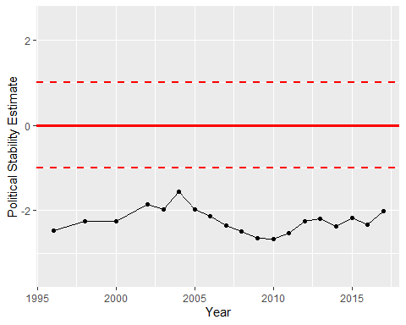

Political Stability Trend